

**GAM3YA APP**

**Software Engineering**

**Presented to: DR. Sherif el Kasas**

**Presented by:**

**Rafik Yacoub 900194127**

**Amr Sallam 900196011**

**George Bassem 900181047**

**Mohamed Hesham 900192833**

Link to video describing the app: <https://drive.google.com/file/d/1CCTjbkBgjikS_5dcQaS7hghCVaNf08fB/view?usp=sharing>

1) Login Screen (min. 0 – 0:30)

You can:

* Login
* Create new user
* Choose forget password

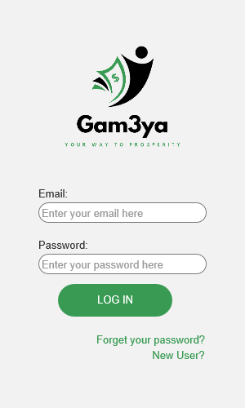

2) Create new user screen (min 0:30 – 1:34)

You will need to type in:

* Full name
* Age
* Email
* Phone number
* National id
* Password
* Governorate
* Address
* Currency
* Selection of payment method
* Range of payment
* Read terms and conditions, then accept them
* Create account

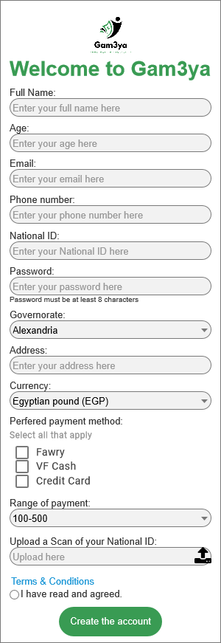

3) Choose forget password from login screen (min 1:40 – 1:51)

* type e-mail
* choose to send a code to your e-mail

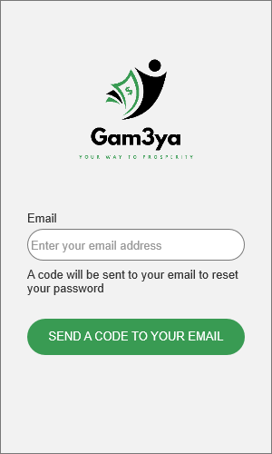

4) Code entry after received on e-mail (min 1:51 – 1:56)



5) Home screen (min 2:10 – 2:25)

The user has multiple choices to choose from, such as:

* create a gam3ya
* search for a gam3ya
* search for a friend
* user guide
* terms and conditions

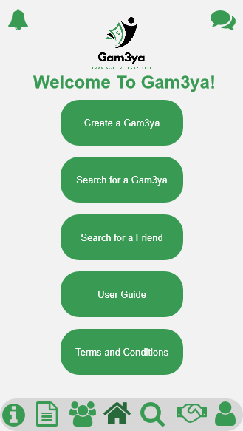

6) Creating a gam3ya (min 2:25 – 3:33)

The user should type in the:

* gam3ya’s name
* payment per person
* total gam3ya value
* number of cycles
* choose frequency
* max number of participants
* start date
* upload picture for the gm3ya
* agree on the terms and conditions

After that the user should start the gam3ya

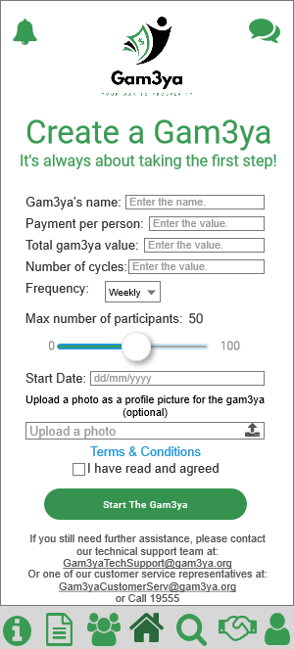

7) Searching for a gam3ya (min 3:41 – 4:17)

User can search for gam3ya by either:

* searching by name
* by applying filters (ex. Frequency)

after that, the user request to join his preferred gam3ya

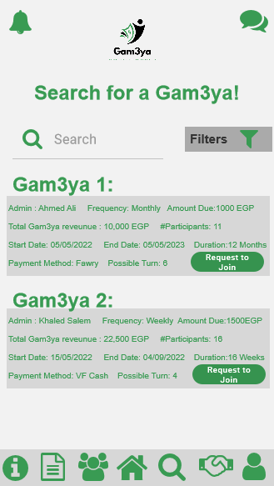

8) search for a friend (min 4:22 – 4:33)

User can search by name

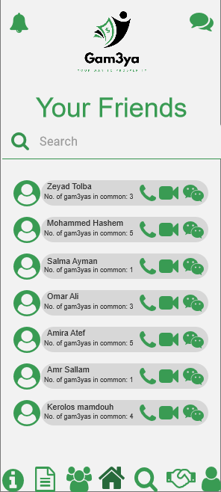

9) User can call his friend after search (min 4:33 – 4:39)

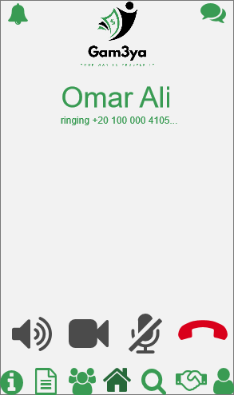

10) User can video call his friend (min 4:39 – 4:46)

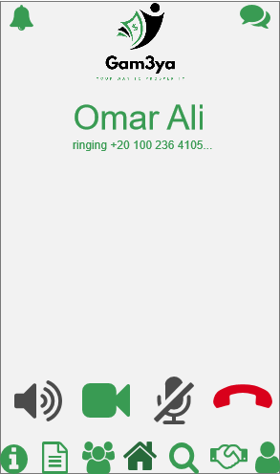

11) user can also chat with his friend (min 4:50 – 5:10)

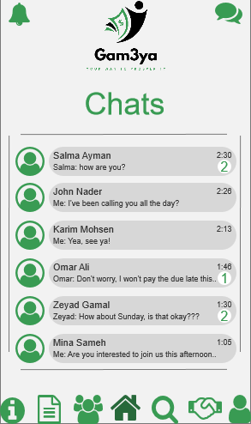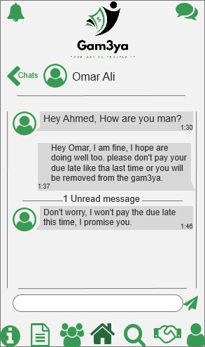

13) Choose user guide from home screen (min 5:13 – 5:20)

To get help regarding using the app

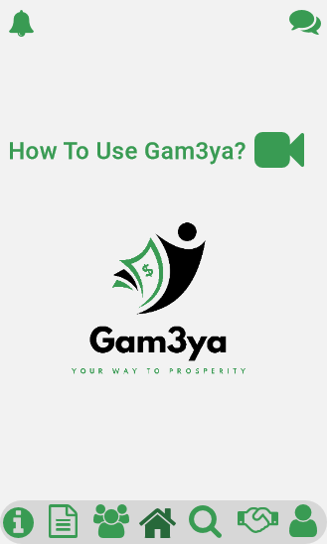

14) Choose terms and conditions from home screen (min 5:22 – 5:26)

15) Choose the info page from home screen (min 5:30 – 5:38)

This page includes all the information about gam3ya app

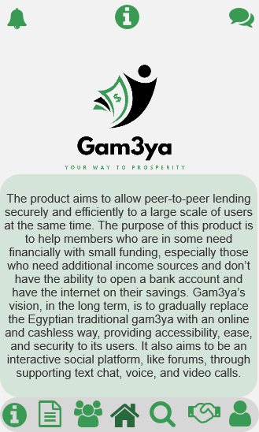

16) Choose to fila a complaint from home screen (min 5:42 – 6:13)

In this page, the user:

* choose the type of complaint
* describe the problem that faced him in detail
* upload a screenshot to clarify the problem

then submit the complaint

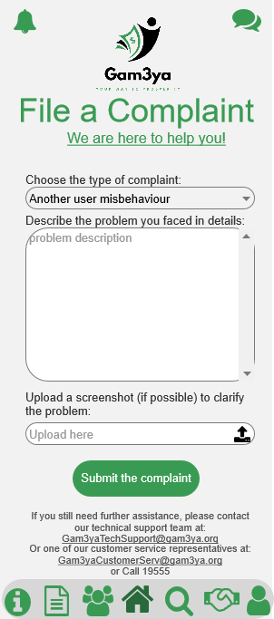

17) Choose my gam3ya’s from home screen (min 6:52 – 7:00)

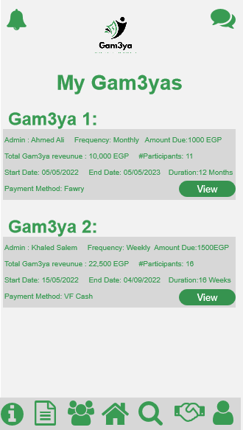

18) View info about the gam3ya such as: (min7:01 – 7:24)

* Admin info
* Frequency info
* Amount due
* Total gam3ya revenue
* Number of participants
* Start date
* End date
* Duration
* Payment method

Then choose to either pay or withdraw

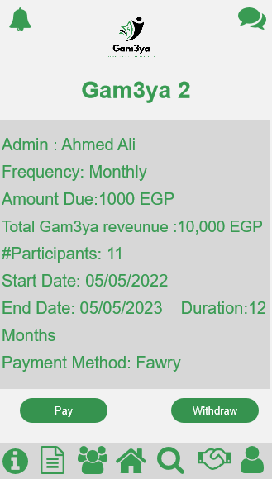

19) Choose to pay (min 7:25 – 7:33)

The user has 3 options of payment to choose from:

* Fawry
* VF-cash
* Credit card

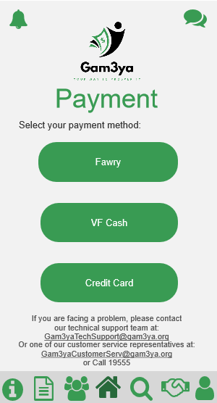

20) Choose fawry payment (min 7:34 – 8:02)

The user is given a payment code and asked to go to the nearest fawry branch to pay using the code.

After the payment transaction is done, the user is asked to enter the transaction ID on the receipt to confirm transaction.

Then press proceed

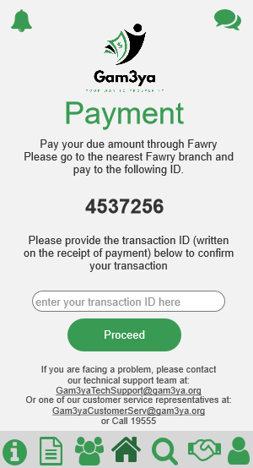

21) Choose VF-cash payment (min 8:09 – 8:28)

The user is given a payment code and asked to go to the nearest Vodafone branch to pay using the code.

After the payment transaction is done, the user is asked to enter the transaction ID on the receipt to confirm transaction.

Then press proceed

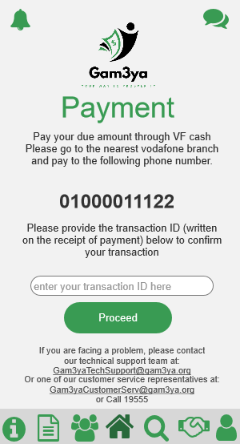

22) Choose the credit card payment (min 8:35 – 9:04)

The user is asked to add the. credit card info, such as:

* Card number
* Expiry date
* Cvv
* Card holder name

Then press proceed

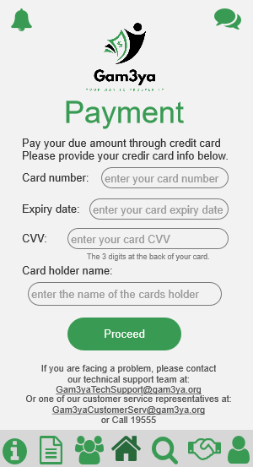

23) Choose to withdraw (min 9:04 – 9:15)

The user has 3 options of withdrawal to choose from:

* Fawry
* VF-cash
* Credit card

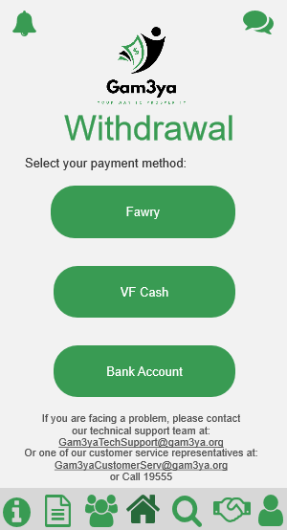

24) Choose withdrawal through fawry (min 9:15 – 9:27)

The app will give the user a code to withdraw his money using it from the nearest fawry branch.

Then the user press done

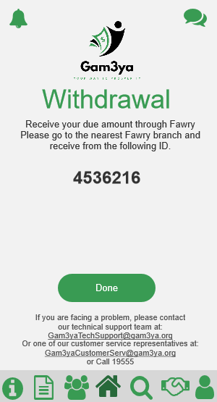

25) Choose withdrawal through VF-cash (min 9:34 – 9:37)

The app will give the user a code to withdraw his money using it from the nearest Vodafone branch.

Then the user press done

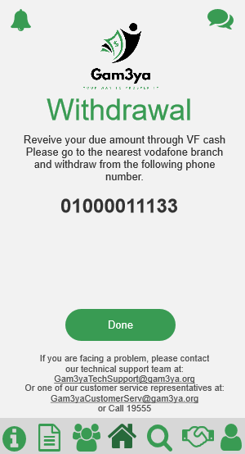

26) Choose withdrawal through credit card (min 9:38 – 10:03)

The user is asked to input his:

* Bank name
* Account number
* IBAN
* Account holder name

Then press proceed

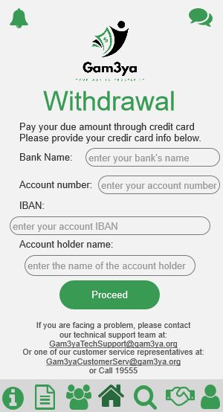

27) Choose my profile from home screen (min 10:14 – 10:46)

This page displays:

* Age
* Mobile number
* Email address
* Address
* National ID
* Currency
* Preferred method of payment
* Number of completed gam3yas
* Number of current gam3yas
* Number of friends
* Next amount due
* Next due date

The user has the option to edit the following:

* Mobile number
* Email
* Address
* Currency
* Preferred method of payment

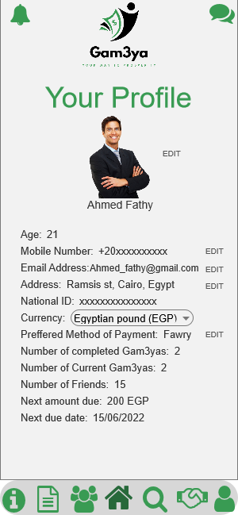

28) Choose notifications from home screen (min 10:51 – 12:23)

This menu views the notifications for the user, the payments due (and he is given the option to pay now), and the friend requests he has.

He has the option to either:

* Accept the request
* Reject the request

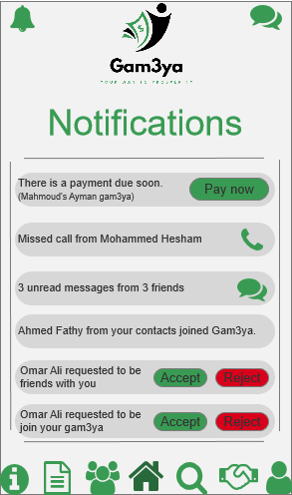

29) Accepting the friend request (min 11:55 – 11:58)

Accepting the request will display the user following info:

* Age
* Mobile number
* Email address
* Currency
* Number of completed gam3yas
* Number of current gam3yas
* Number of friends

